**Replicating Excel Tables in Power BI with Selectable Columns**

Recently I was tasked with converting some Excel tables into Power BI with the additional functionality of making the columns selectable. The Power BI extract would need to look exactly the same which meant including the columns in the same order and keeping any formatting of the individual fields. I couldn’t find anything that covered the scenario so I thought I’d put something together about how I did it.

I started with a dataset in a matrix that replicated the table structure of Excel (shown below) each column had the individual field formatted to show the correct data format. The Product was displayed within its product group and by month.

The first step was to enable users to select the columns they wanted to be displayed in the table. In order to create any individual visualizations I wanted to keep the original table so I started by creating a duplicate of the current table in Power Query Editor

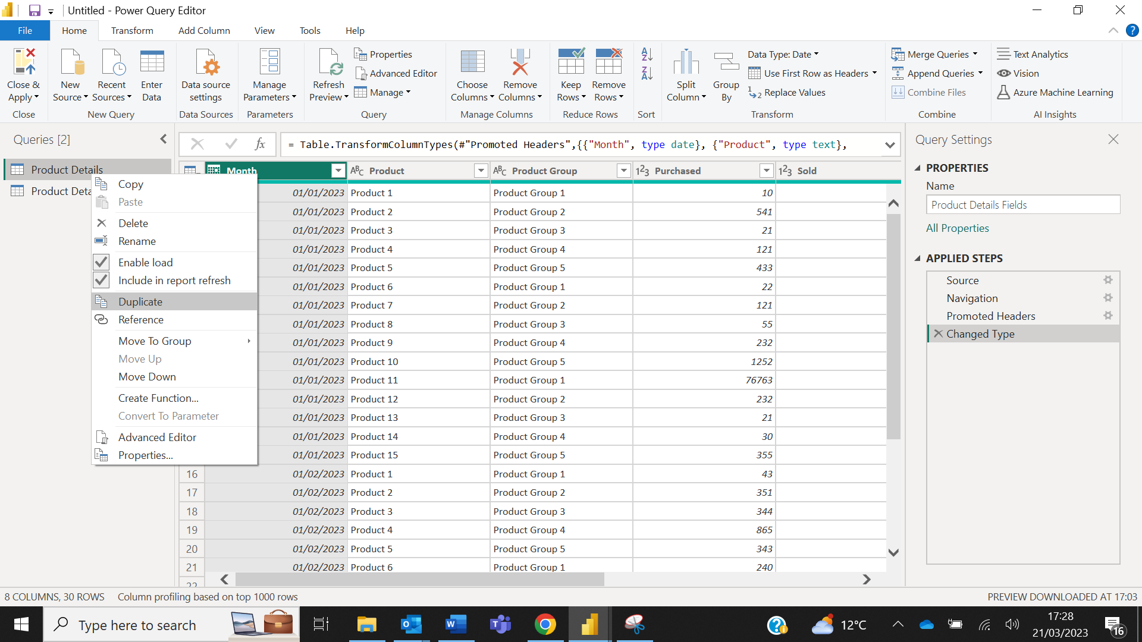

The duplicate table was then unpivoted to show a list of values for column selection. In this case Purchased, Sold, Sale Total, Cost Total and Profit were unpivoted. Select and right click the columns to unpivot.

This created an Attribute and Value column with all the field names from the unpivoted fields contained within the Attribute column.

After applying the changes in Power Query Editor, I replaced the fields in the matrix with the fields from the new table. Month, Product Group and Product were still in the original structure, so they just replaced the existing fields under the Row section. Then to replicate the same layout as the original the Attribute field was added to the Columns section and Value field to the Values section.

By also including the Attribute field to a slicer the columns within the matrix become selectable, allowing you to activate or deactivate as many as you need.

However, when looking at the full table with all columns selected (shown below), the columns are now in a different order and it has also lost any formatting for the different fields. From Power Query Editor I could sort by ascending or descending but this wouldn’t work for this particular table layout.

To amend the column order I created a new table in Power Query Editor using the column names from the table and added a sorting order ID.

Then in the modelling view I linked the Name filed containing the column names from my sort order table to the Attribute field used in the table previously created.

Switching back to the report view I created a calculated column for the sort order in the table with the Attribute column.

Selecting the Attribute column and using the Sort by Column function from the Column tools ribbon I was able to sort Attributes by the calculated sort order column.

This reordered the columns into the original order (shown below).

The final issue was to address the formatting that had been lost by converting multiple fields into one column.

For this to work I created a measure that looked for a sting in the Attribute field and then formatted the value in the Value field. To be able to calculate totals at the month and product group level I used SUM within the FORMAT expression. Using SELECTEDVALUE within FORMAT would only work on the individual row level.

In this table example I had two quantity fields which needed to be whole numbers and three currency fields (Profit, Total Cost and Total Sales). The DAX Measure below searches for the word ‘Profit’ or ‘Total’ within the Attribute and applies a format of currency to the Value field while retaining the ability to calculate the totals, to all other fields it applies a whole number while again retaining the ability to calculate totals.

DAX Expression:

Value Measure For Multiple Data Formats = IF(OR(CONTAINSSTRING(SELECTEDVALUE(Table'[Attribute]),"Profit"),CONTAINSSTRING(SELECTEDVALUE('Table'[Attribute]),"Total")),FORMAT(SUM(Table'[Value])),"£#,##0.#0"),FORMAT(SUM('Table'[Value])),"#"))

Finally replacing the Value field in the Values Section of the matrix with the newly created measure will give you the original layout with the increased functionality of selecting columns.

Final Output:

**Power BI - Multiple Data Formats In One Column**

I was recently working on an update a matrix in Power BI to make the columns selectable. This was achieved through unpivoting the fields and using the Attribute in a slicer as the selector, however, the individual values now combined into one column all had the same data format. The original data formats were currency and whole numbers.

There were some solutions that worked on the individual level using SELECTEDVALUE to format the value but this wouldn’t work when for totals at a higher hierarchy level, in this case I was working with products, product group or month. See below:

For this to work for the group and month level calculations I had to SUM the values within the FORMAT expression. In the example below I had two quantity field which needed to be whole numbers and three currency fields (Profit, Total Cost and Total Sales). The DAX Measure searches for the word ‘Profit’ or ‘Total’ within the Attribute and applies a format of currency to the Value field while retaining the ability to calculate the totals, to all other fields it applies a whole number while again retaining the ability to calculate totals.

DAX Expression:

Value Measure For Multiple Data Formats = IF(OR(CONTAINSSTRING(SELECTEDVALUE(Table'[Attribute]),"Profit"),CONTAINSSTRING(SELECTEDVALUE('Table'[Attribute]),"Total")),FORMAT(SUM(Table'[Value])),"Currency"),FORMAT(SUM('Table'[Value])),"#"))

Final Output:

